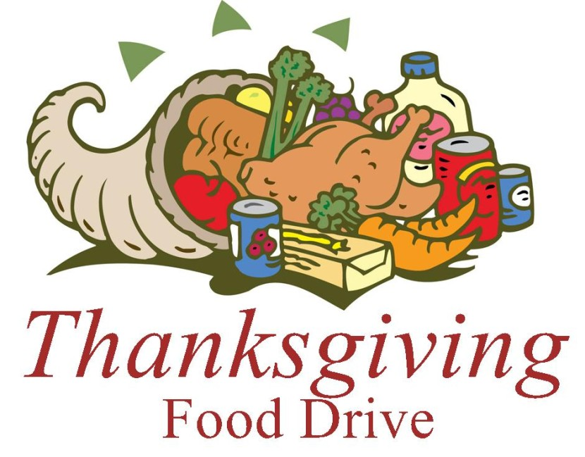

Let’s make a difference!
Please join us in collecting unexpired, undented canned and non-perishable food items for families in need during this holiday season.
Our food drive will run from Friday, October 31 through Wednesday, November 18, 2025. A food suggestion calendar for each day is attached.
Thank you!

