 |  | November 2025
Sunday | Monday | Tuesday | Wednesday | Thursday | Friday | Saturday
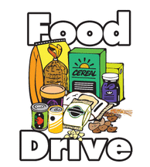 |  |  |  |  | 10/31  Boxed Potatoes | 11/1
11/2 | 11/3 | 11/4 | 11/5 | 11/6 | 11/7 | 11/8
 | Box Macaroni & Cheese | Stuffing Mix | Pasta/Rice | Peanut Butter and Jelly | Oatmeal/  Cereal
11/9 | 11/10 | 11/11 | 11/12 | 11/13 | 11/14 | 11/15
 | Spaghetti Sauce/Gravy | Canned Fruit/Cranberry Sauce | Canned Vegetables | Canned Soup | Snacks - Pretzels, Goldfish, Crackers
11/16 | 11/17 | 11/18 | 11/19 | 11/20 | 11/21 | 11/22
 | Dessert Mix | Juice Boxes
11/23 | 11/24 | 11/25 | 11/26 | 11/27 | 11/28 | 11/29

