 |  | November 2024
Sunday | Monday | Tuesday | Wednesday | Thursday | Friday | Saturday
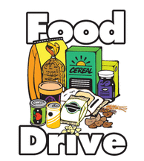 |  |  |  |  | 11/1  Boxed Potatoes | 11/2
11/3 | 11/4 | 11/5 | 11/6 | 11/7 | 11/8 | 11/9
 | Box Macaroni & Cheese | Stuffing Mix | Pasta/Rice | Peanut Butter and Jelly | Oatmeal/  Cereal
11/10 | 11/11 | 11/12 | 11/13 | 11/14 | 11/15 | 11/16
 | Spaghetti Sauce | Canned Fruit/Cranberry Sauce | Canned Vegetables | Canned Soup | Snacks/ Pretzels, Goldfish, Crackers
11/17 | 11/18 | 11/19 | 11/20 | 11/21 | 11/22 | 11/23
 | Dessert Mix | Juice Boxes
11/24 | 11/25 | 11/26 | 11/27 | 11/28 | 11/29 | 11/30
 |  |  |  | 